**CONGRESSWOMAN ALMA S. ADAMS, Ph.D.**

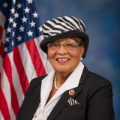

**NC-12 Military Service Academy Appointees**

**Class of 2024**

|  |  |  |
| --- | --- | --- |
| **Ethan Schneider**  U.S. Naval Academy | **Olivia Hommes**  U.S. Air Force Academy | **Cameron Helmendach**  U.S. Merchant Marine Academy |
| **Chris Torres**  Military Academy at West Point | **Tanner Gresham**  Military Academy at West Point | **Ayush Padhi**  U.S. Naval Academy |